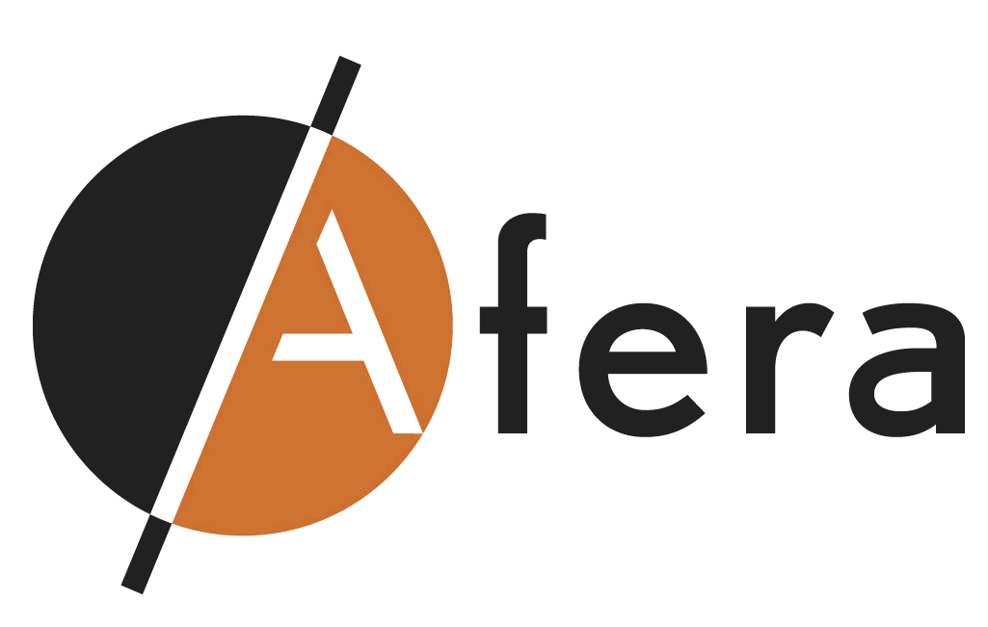AGENDA

**Afera Marketing Committee Meeting**

**DoubleTree by Hilton Hotel, Amsterdam  
3 February 2015, 13.00-17.30 hrs.**

***Room: Glasgow 2***

1. **Opening/Agenda/Competition Law Compliance** MP
2. **Minutes and actions meeting 1 October 2014**

2.1 Converter input (update on any issues raised by converters) MP

2.2 Progress MKC topic driven WG’s developed according to Afera’s mission to ‘grow

the pie’ for all companies in the European SA tape value chain:

- Social Media Programme *(status report under Agenda item 3)* MP

- Website Management SB

- Education Awareness – *understanding adhesives document final text and how*

*can we support the TC in getting adhesive tape on engineering degree in the syllabi*

*of universities/engineering schools*

- Membership Recruitment

- General Communications – *ongoing*

*-* Annual Conference - *ongoing*

2.3 Feedback SC on question ‘value Afera membership for commodity producers’ MP

1. **Update Initiative Creative Concept for “Ideas that Stick”** BvL
   1. Results and way forward interviews designers
   2. Further content development via blogs, twitter approaches/followers
   3. Way forward and plans towards our Marseille conference in October

**4. Afera Marketing Committee as Review Board**

4.1 Brainstorm on future captains of industry debates MP/All

4.2 Market trends and statistics presenting at Afera’s annual conferences (evaluation 2014

and brainstorm 2015 and beyond)

**5. Afera Annual Conference 2015**

5.1 Review/consideration comments Dubrovnik conference All

5.2 Theme/topics Marseille conference programme

**6. Afera Media Tools**

5.1 Afera’s digital newsletters – feedback from MKC members All

5.2 Afera’s website *(already discussed under item 2.2)*

**7. Other matters** (please advise any items for inclusion before the meeting) All

1. **Closure and date next meeting** MP